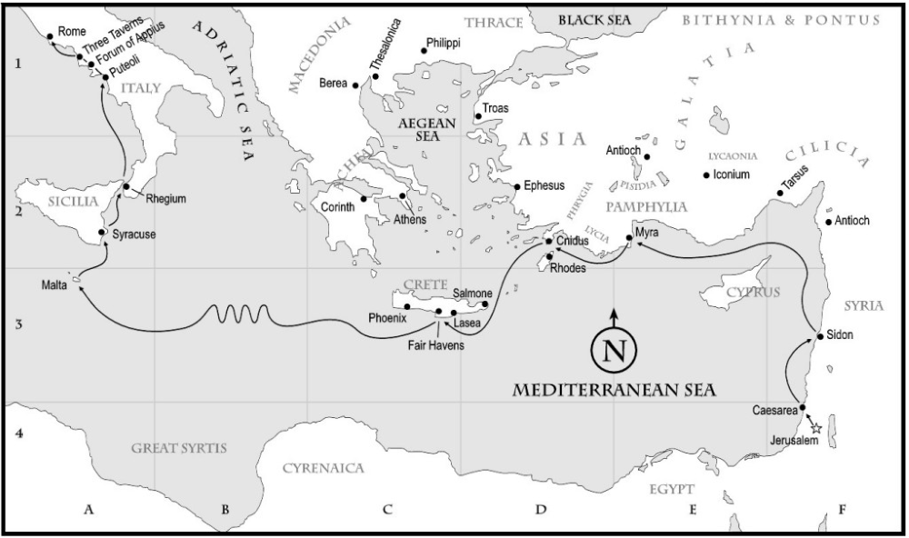

**c. 5**

**Paul Born**

**36**

**Paul Conversion**

**48**

**1st Mission Journey**

**51**

**2st Mission Journey**

**52-53**

**1st & 2nd**

**Thess**

**54**

**3rd Mission Journey**

**57**

**1 Corinth Galatians**

**58**

**2 Corinth Romans**

**62**

**Paul in prison (Rome)**

**Writing of Eph, Philip, Coloss, Phil**

**63**

**Paul Acquitted**

**Heb, 1Tim, Titus**

**63/65**

**1&2 Peter**

**65**

**Paul in prison (Rome)**

**66**

**2 Tim**

**Paul Martyrdom**

**70**

**Jerusalem Destroyed**

**75**

**Jude**

**c.30**

**Jesus Crucifixion**

**90**

**John 1,2,3**

**62**

**James**